# 

**LOGISTICS** **1**

**PART1 - Introduction and Fundamentals** **2**

**PART2: Applied to Recommender Example** **14**

# LOGISTICS

- Logistics:

https://github.com/moorecsys/moorecsys.github.io/

- Conflicting Objectives:

Accuracy, Diversity, Novelty

- Conflicting Stakehodlers:

seller, user, platform user

* Resources
  + https://github.com/irecsys/Tutorial_MSRS/blob/master/Slide_MSRS_ACM%20CIKM%202019.pdf

# 

# PART1 - Introduction and Fundamentals

**Simple Formulation**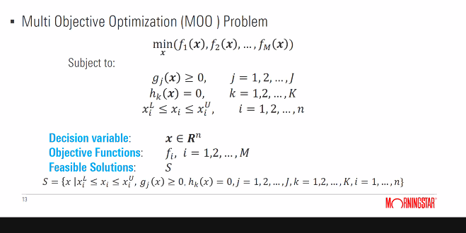

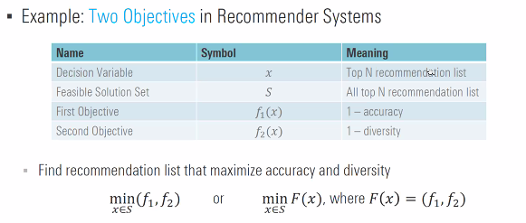

**Simple Example**

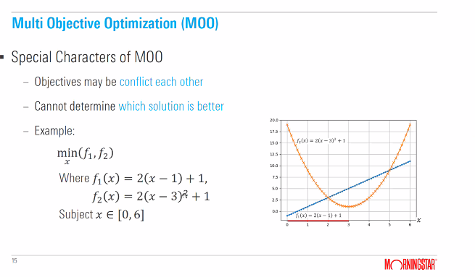

**Look for non-dominated solution (aka Pareto Optimal Solution)**

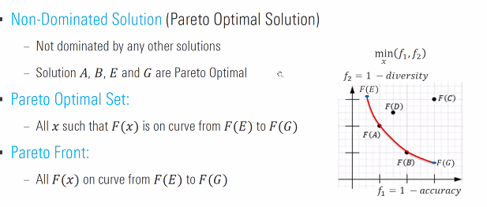

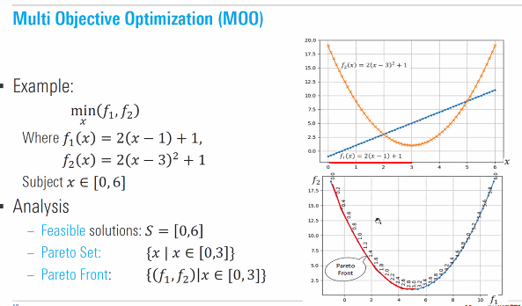

**To Reframe the Problem**

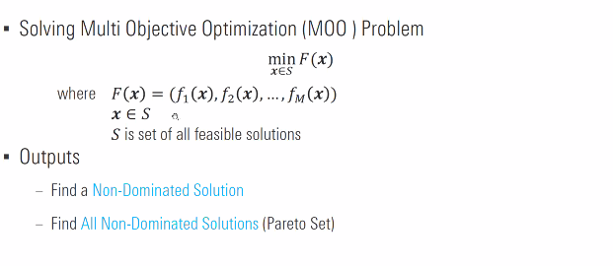

**Different ways to use MOO: user assisted, no assistance, interactive. No DM is very common for recommender system.**

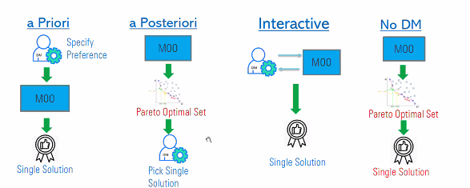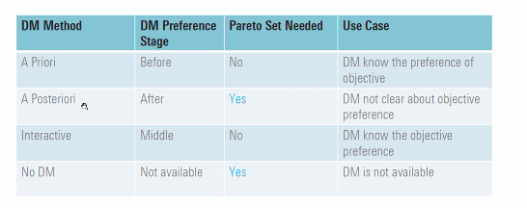

**MOO Algorithms Families**

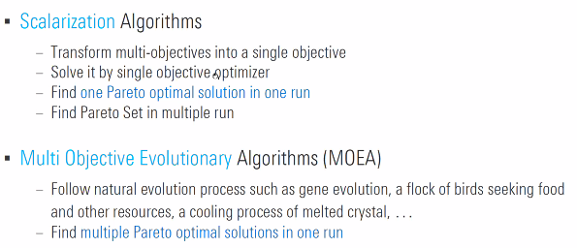

**Scalarization Algorithm (Single Objective): Weight Sum**

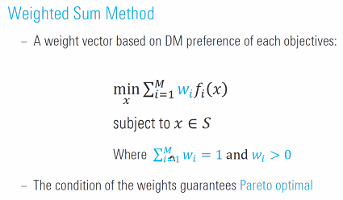

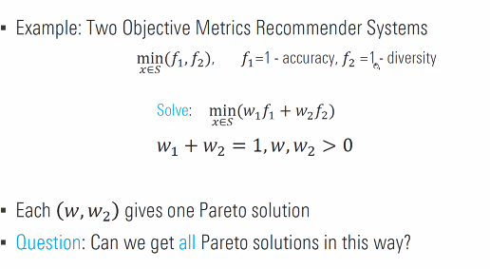

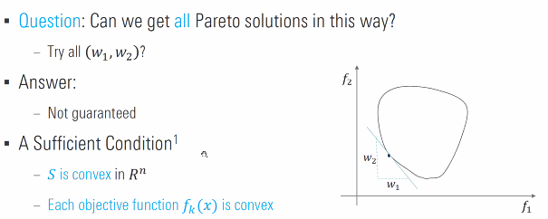

Guaranteed if we have a convex solution

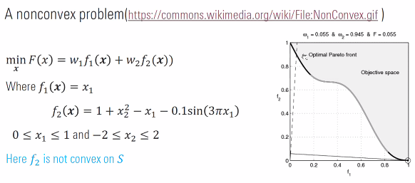

**Scalarization Algorithm (Single Objective): Weight EXPONENTIAL Sum**

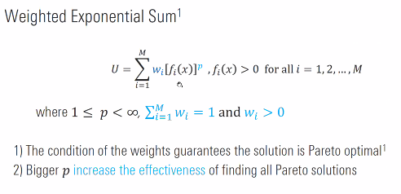

**Scalarization Algorithm (Single Objective): Weight METRIC**

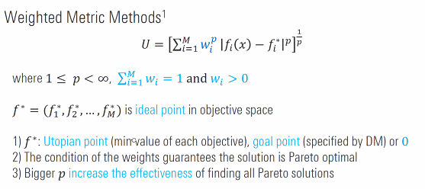

**Scalarization Algorithm Weighted SUMMARY**

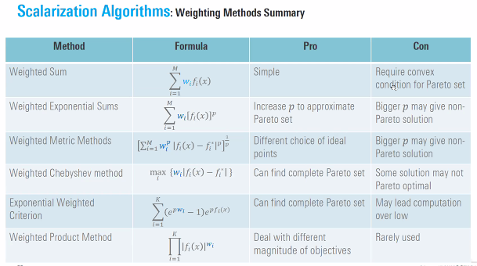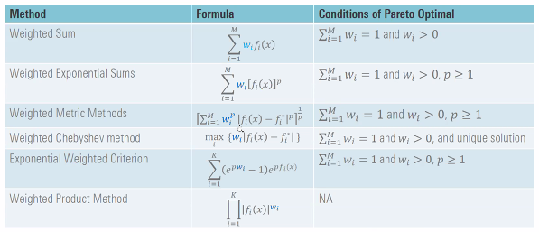

**Scalarization Algorithm: Constraint Method**

**NO CONVEX REQUIREMENT**

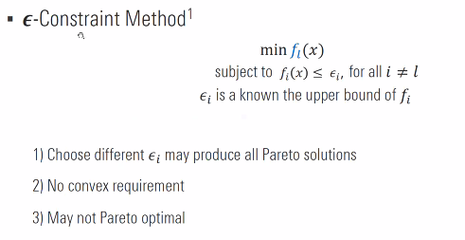

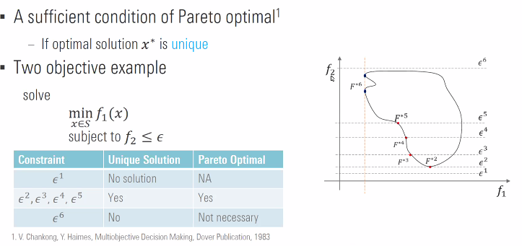

**Scalaraization Algorithm Summary**

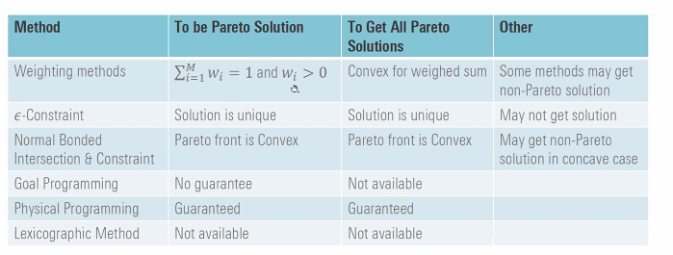

**Multiobjective Evolutionary Algorithm**

Ex: Genetic Algorithm, Particle Swam Optimization, Simulated Annealing

We will focus on genetic algorithm

Benefit of Multi-Objective Algorithm,

Since it’s population based.

But may have higher computation, and convergence issues

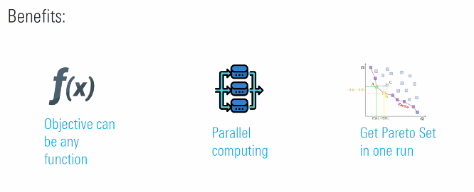

Terminologies:

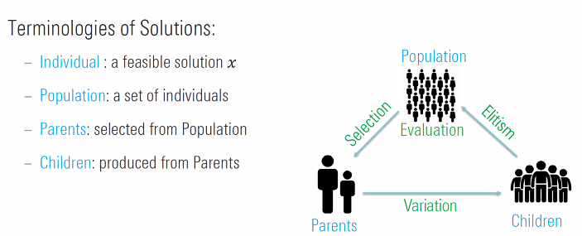

**HOW to Select the Best Pareto Set**

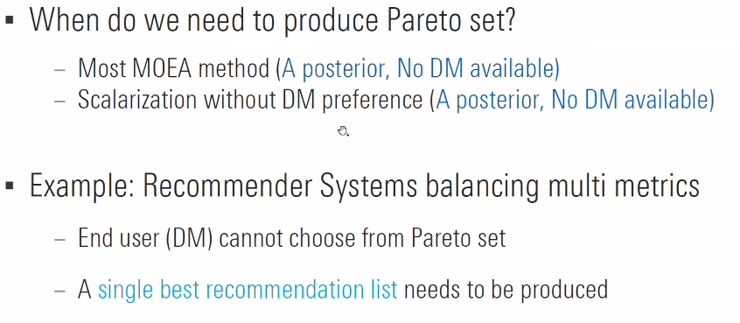

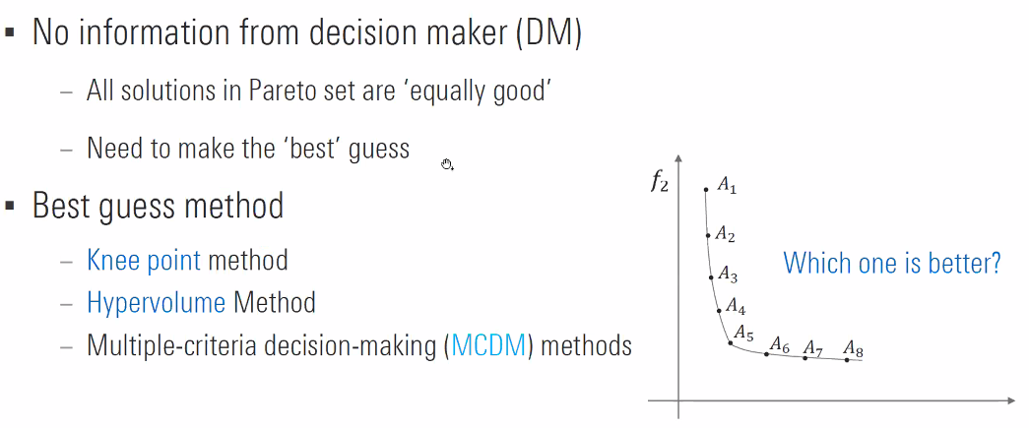

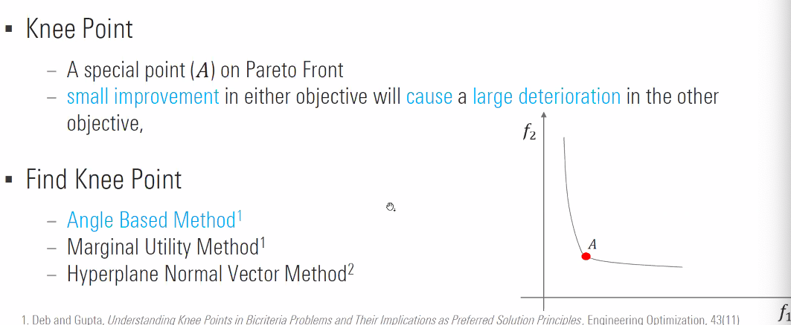

KNEE POINT: this is what I did in Search Monetization !!! But I think we were shifting adRate vs clickRate. It should be sellerRev vs buyer solution.

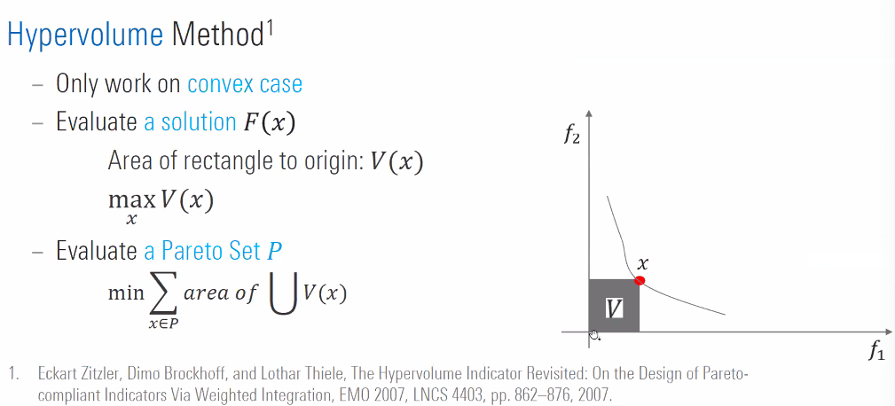

**LIBRARIES**

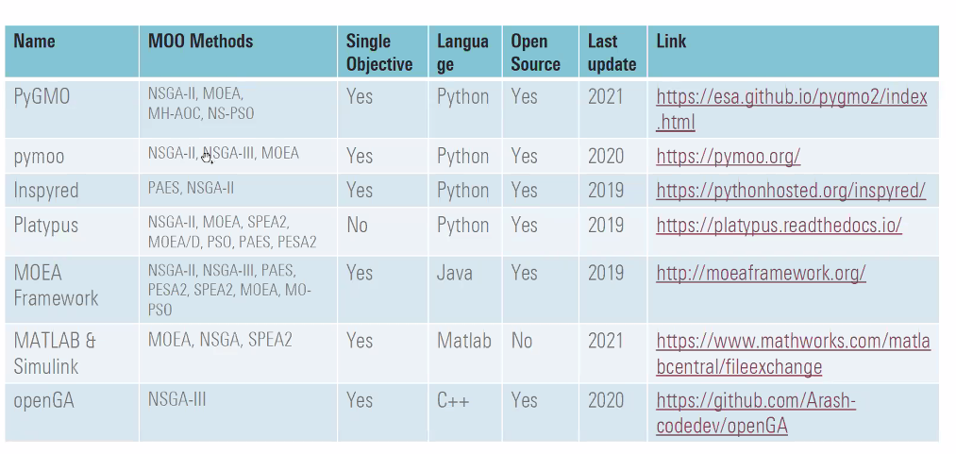<https://pymoo.org/getting_started.html>

<https://platypus.readthedocs.io/en/latest/>

Primary for evolutionary

**SUMMARY OF PART 1**

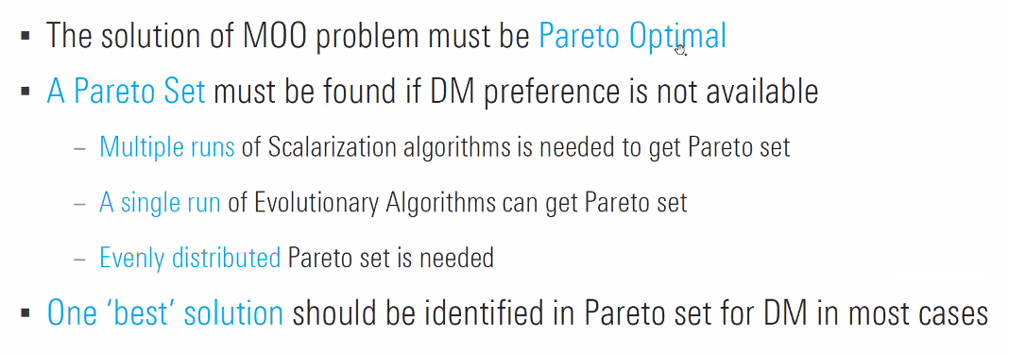

Pareto set: set of optimal solutions

# PART2: Applied to Recommender Example

**Framing the Problem**

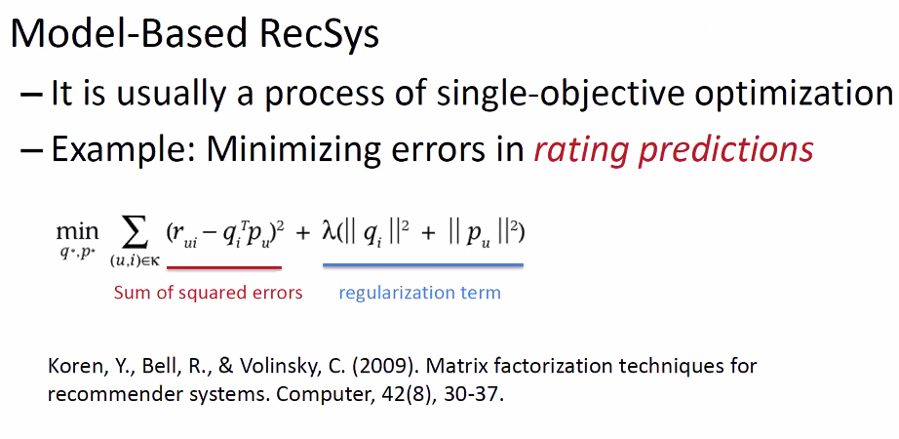

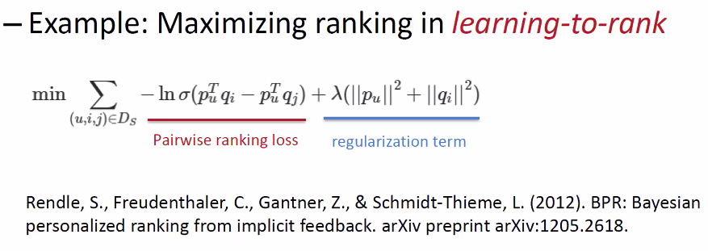

Now, we also need to balance other metrics

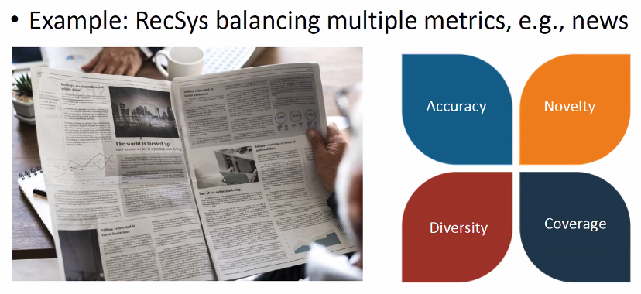

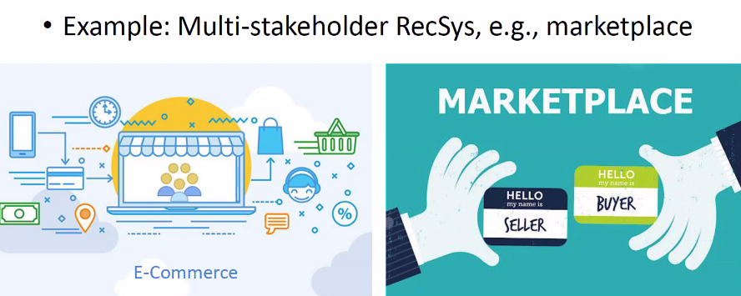

**Context where we may need MOO in recsys/ Examples**

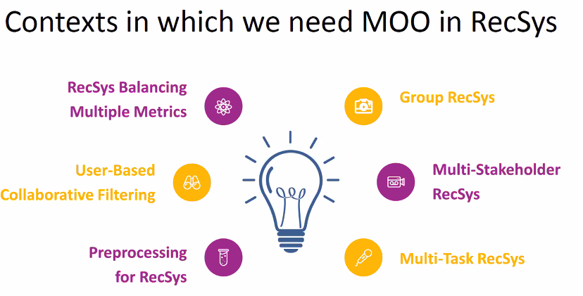

**RECAP**

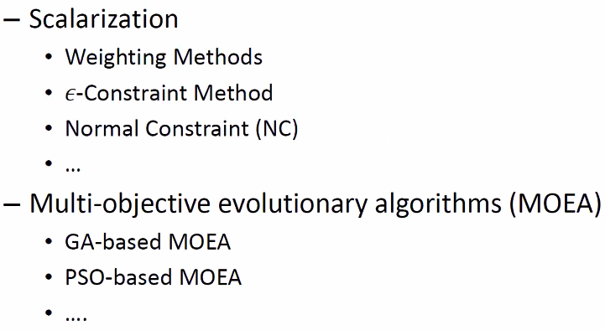

**Example: RecSys Balancing Multiple Metrics**

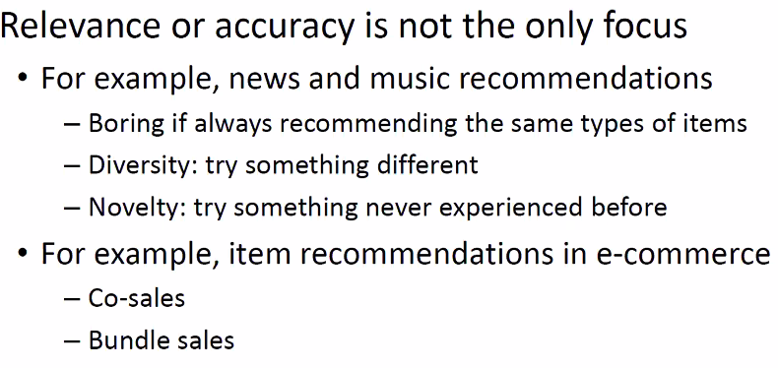

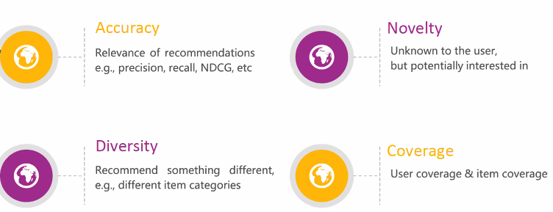

Refer to article on how to measure these metrics

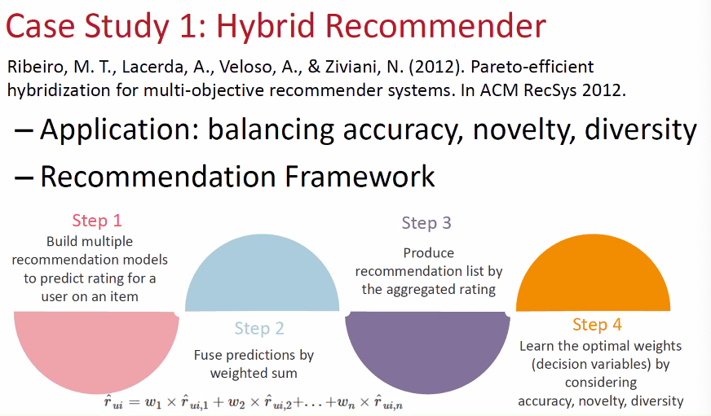

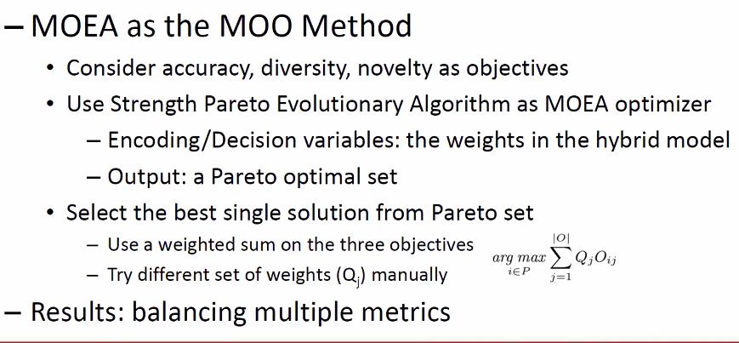

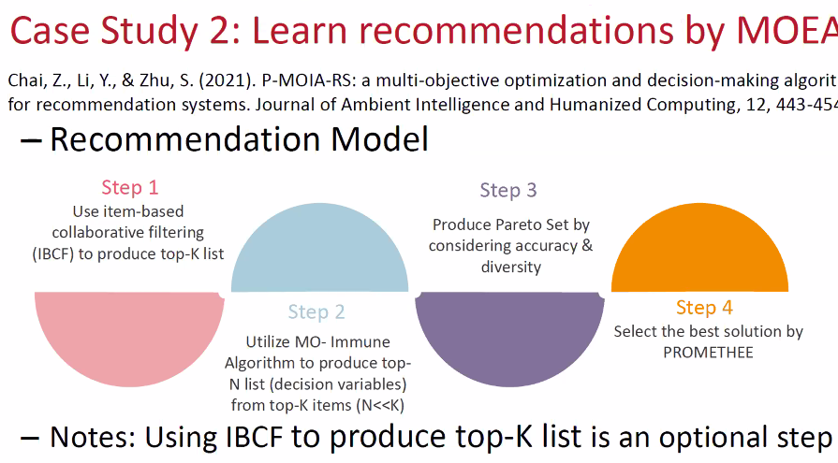

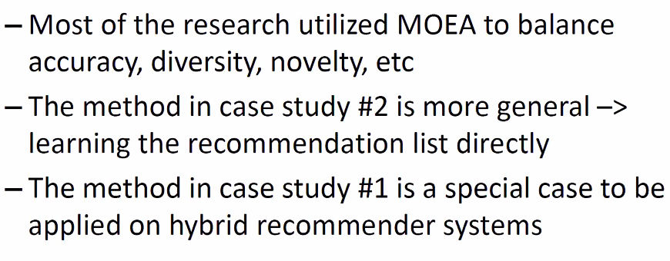

**Example: User Based Collaborative Filtering (UBCF)**

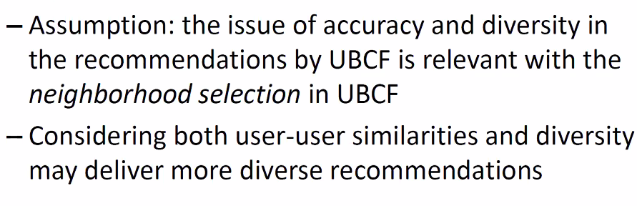

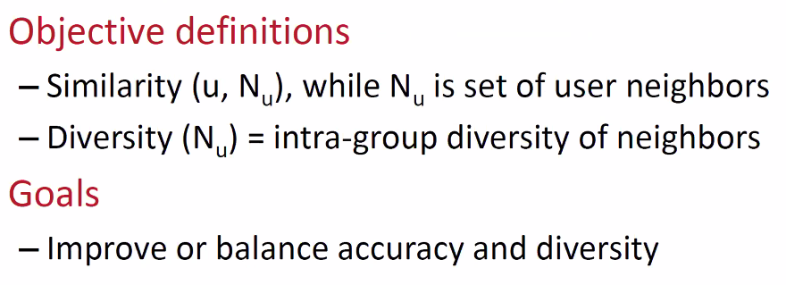

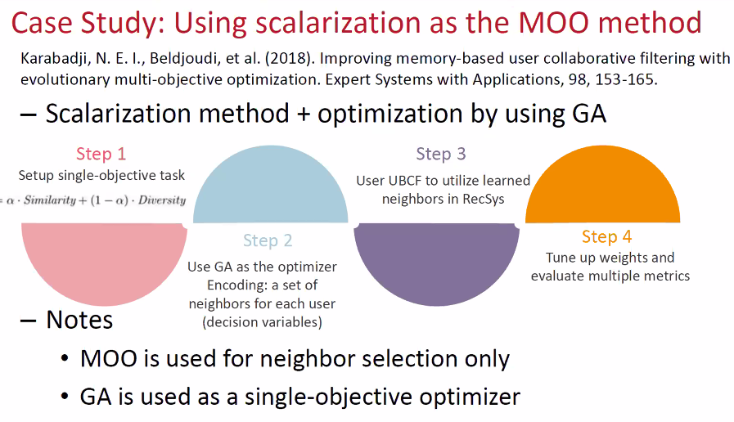

**GA = Genetic Algorith?**

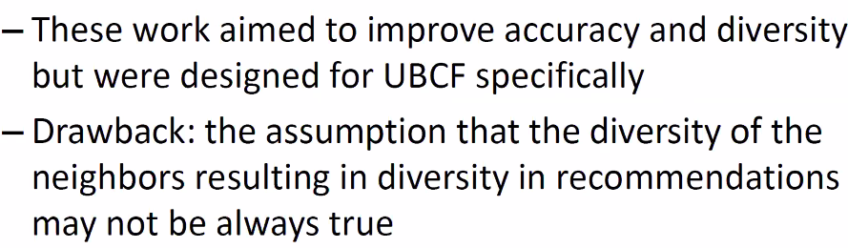

**Example: Multi-Stake RecSys**

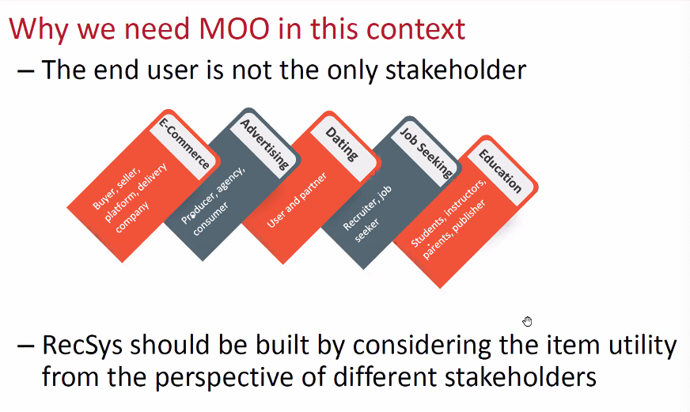

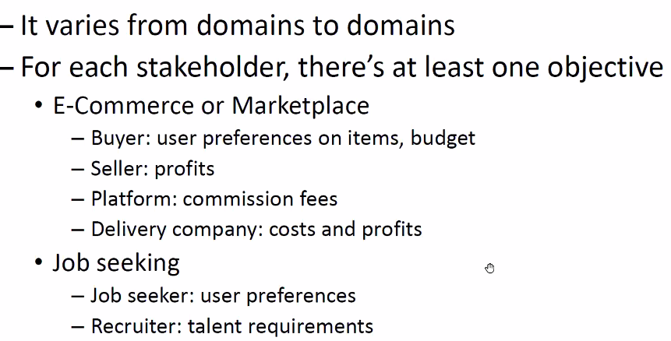

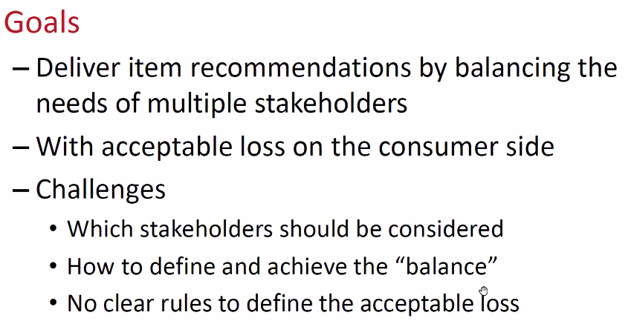

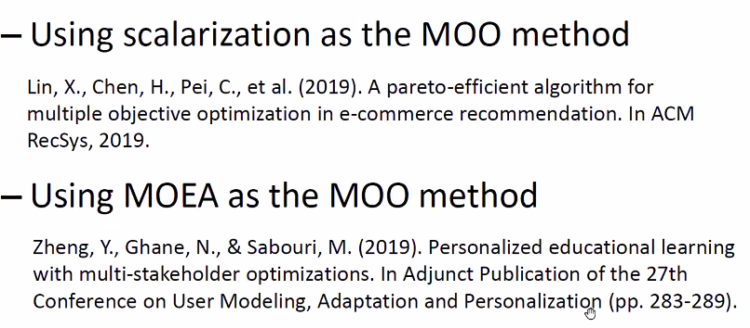

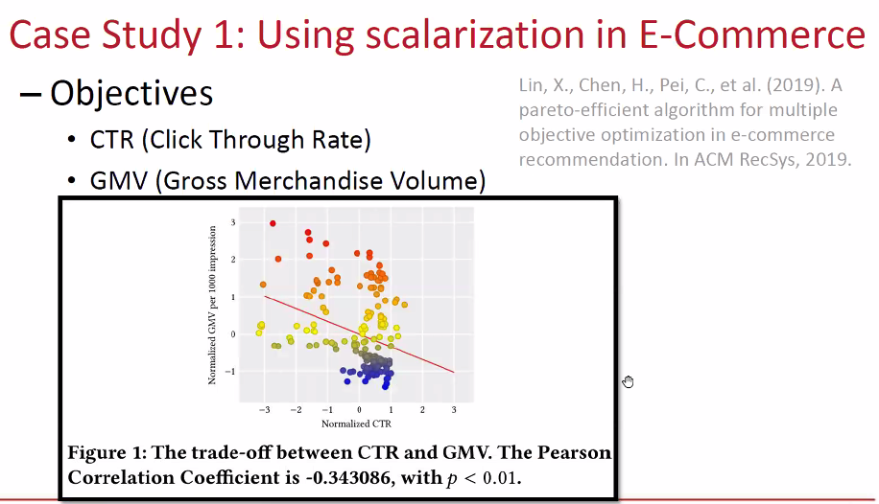

**CTR and GMV are not correlated; improve 1 can actually hurt the other**

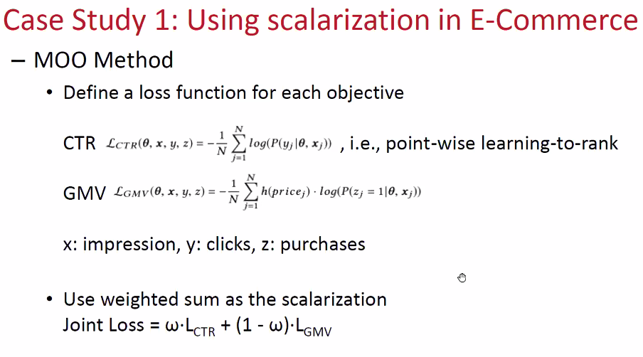

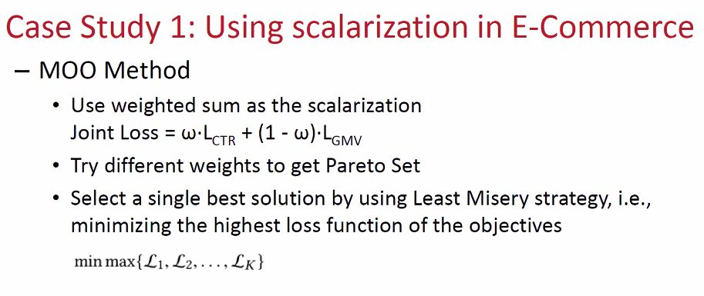

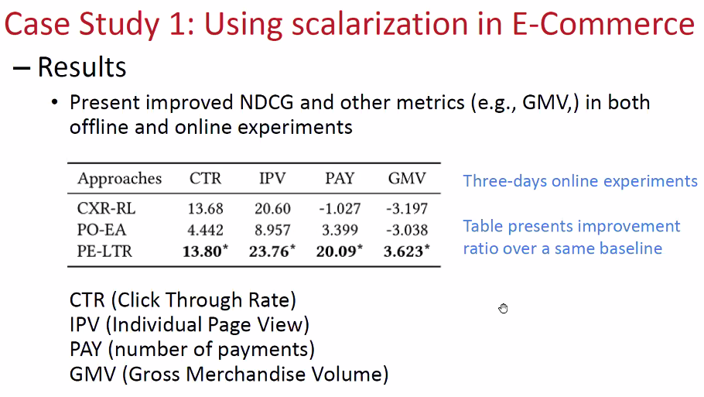

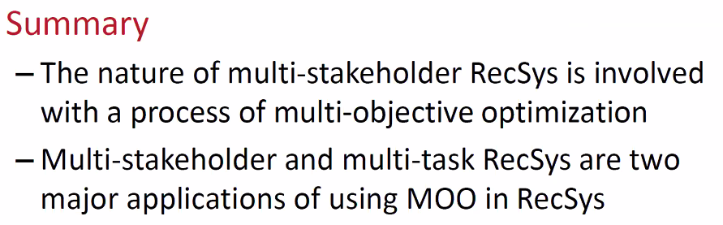

**Example: MultiTask for RecSYS**

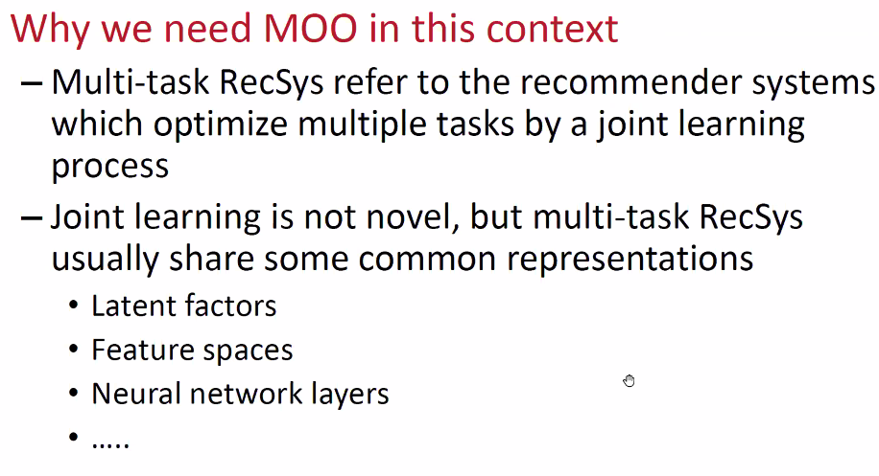

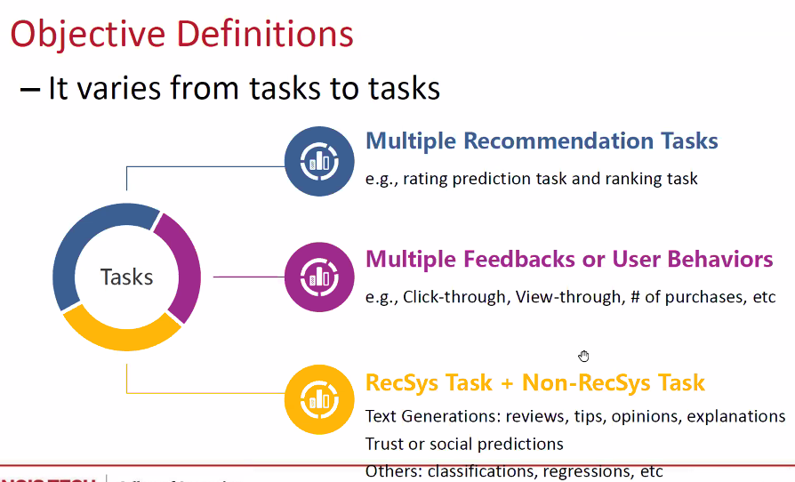

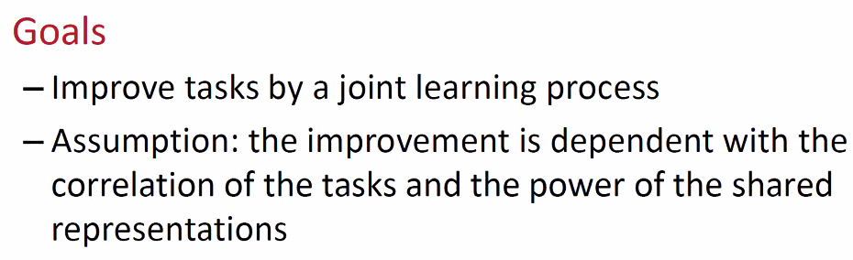

**The tasks has to be correlated and dependent to work well !!!**

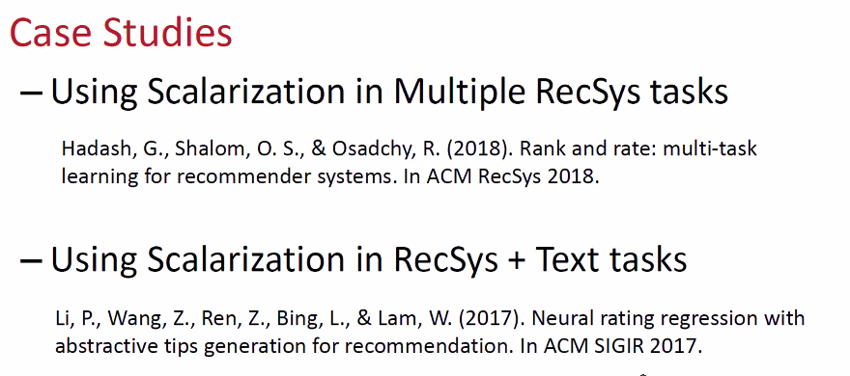

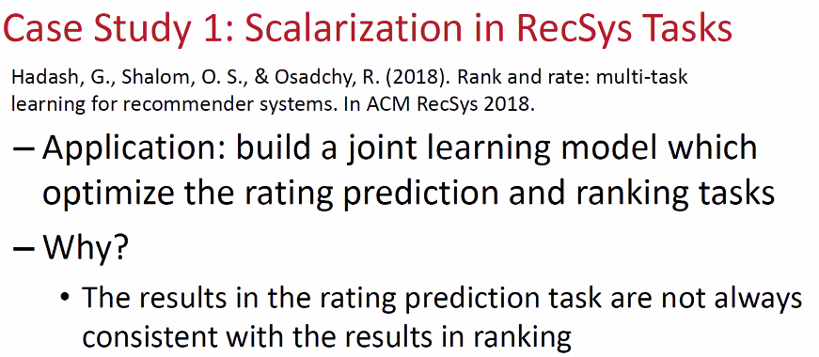

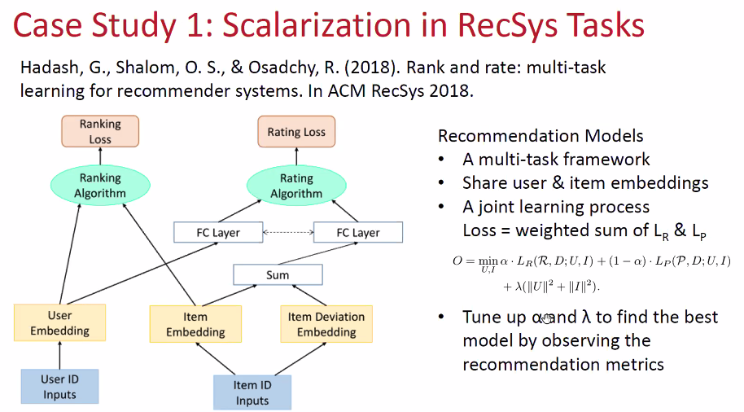

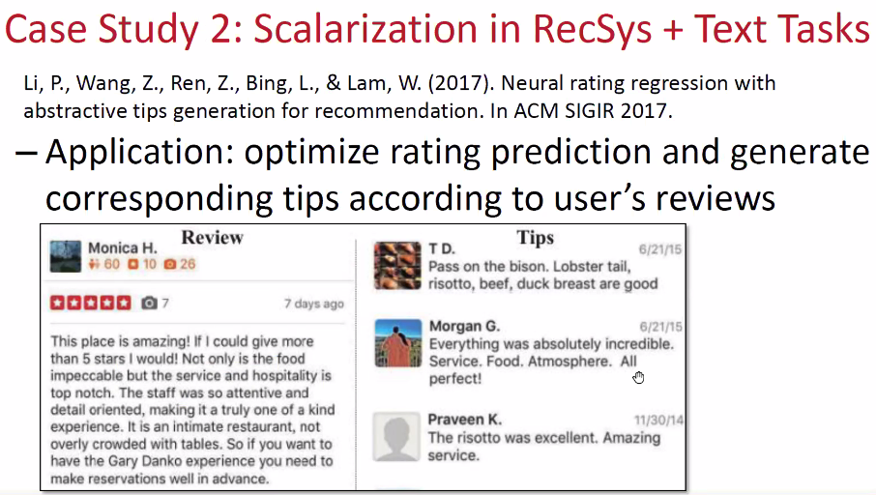

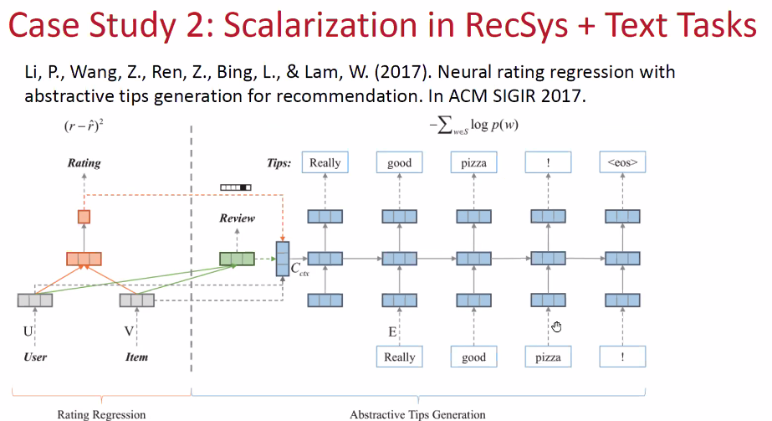

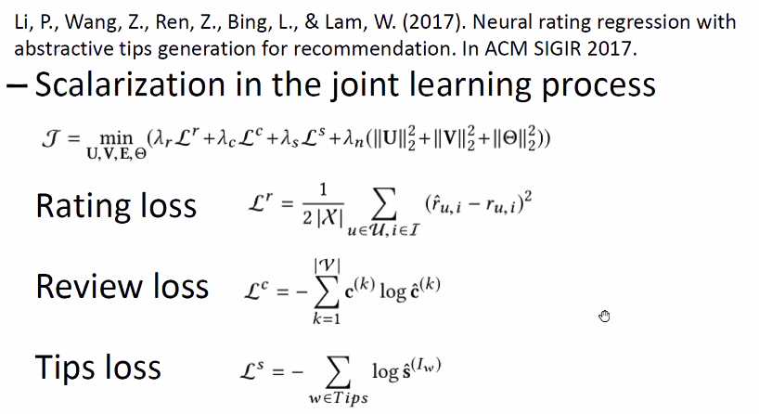

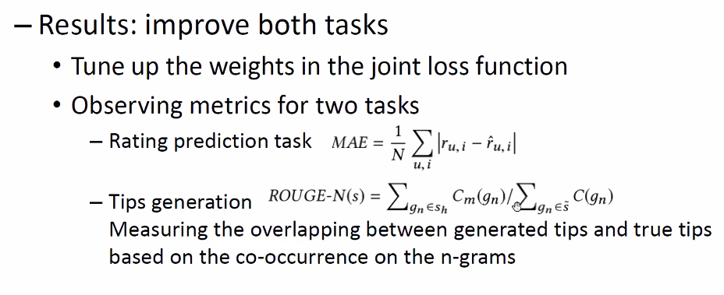

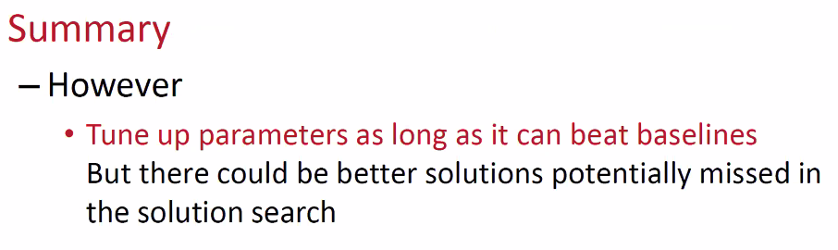

**Example: PreProcessing for RecSYS**

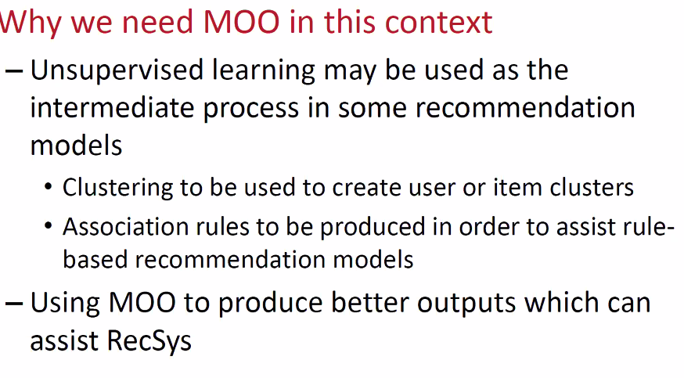

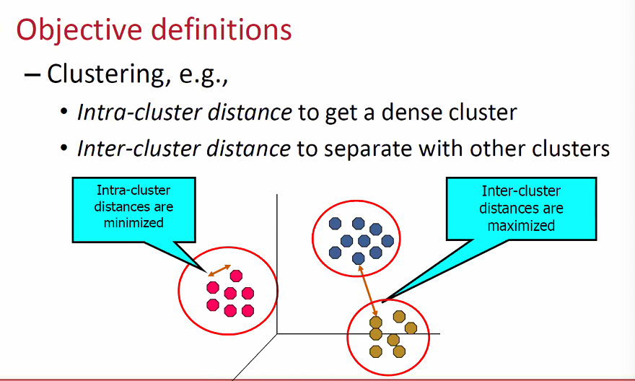

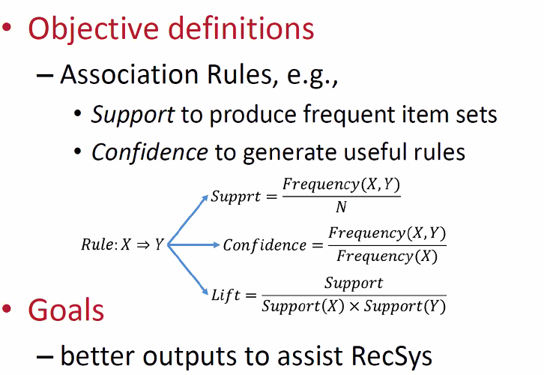

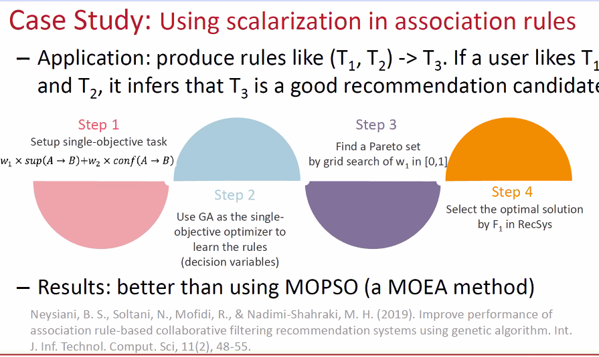

**Example: Group RecSys**

How to balance recommendation for a group where everyone may have different taste

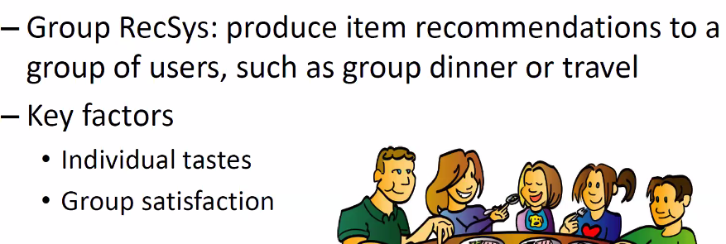

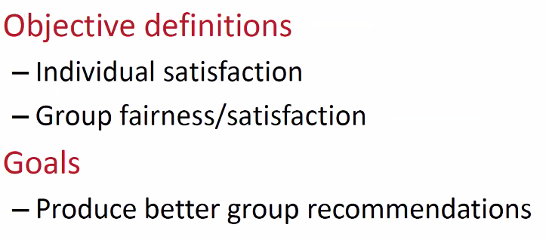

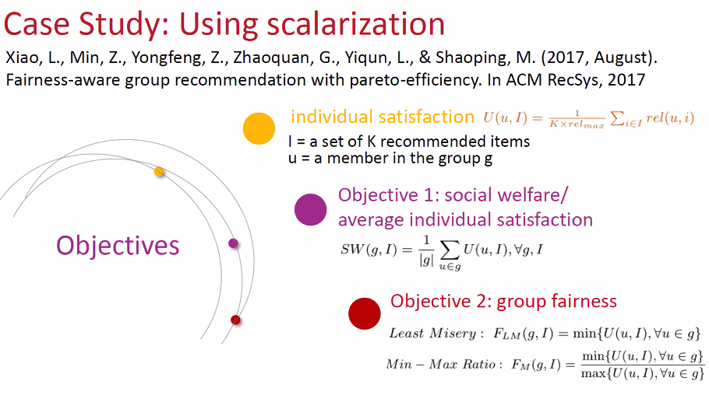

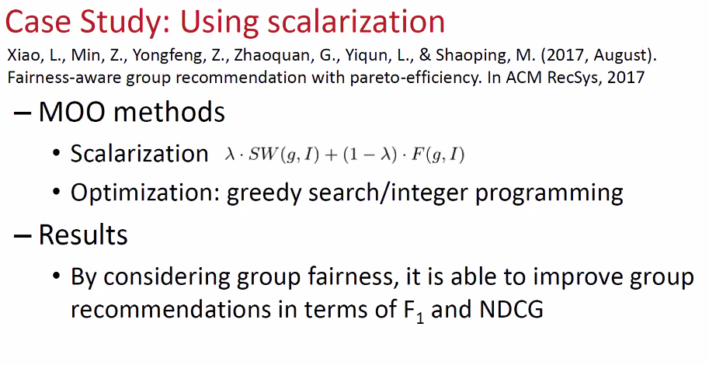

**Part2 Summary:**

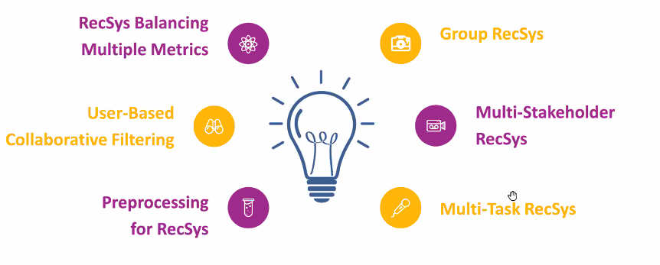

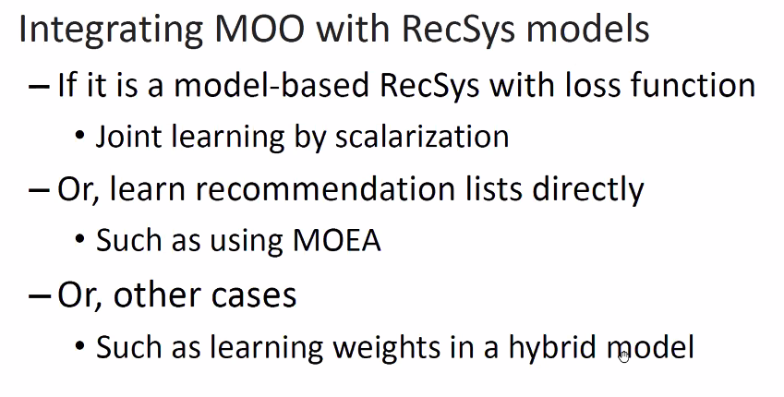

**If rec is a model, design a loss function to include the multiple tasks/stakeholders, and metris**

**Learn recommendation list directly using MOEA**

**Have multiple models, and use MOO to learn the weights of how to combine**

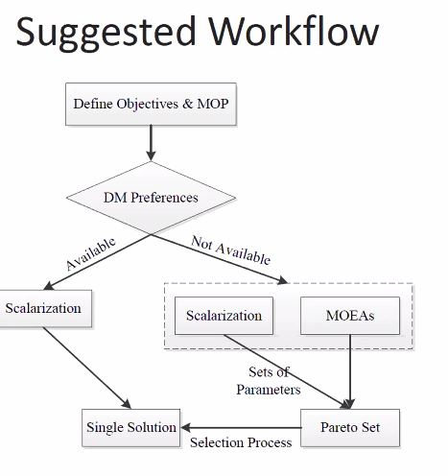

DM: Decision Maker: Preferences: if you know the importance of the metrics?

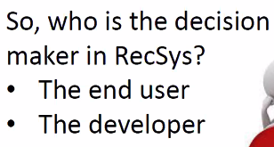

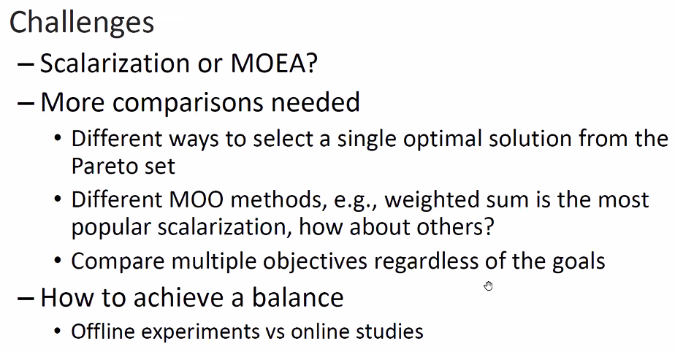

To choose between scalarization or MOEA? Follow the flow chart above.

Scalarization: need to have DM; have to find the best solution in pareto set

MOEA: one single run, but MOE can be heuristic search, will have high computation cost and local convergence.